**University of Hertfordshire  
 School of Computer Science**

**BSc Computer Science**

**Module: Internet of Things**

Assignment: Final Project Report-Football Recognition using RGB Camera

Aoun Muhammad Abbas  
Level 6

2022-23

**Tutor: Alessandra Rossi**

Table of Contents

**Introduction:** 3

**Project Aim:** 3

**Approach:** 3

**Related Work: Object Detection and Avoidance using Mobile Robot using a Stereo Robot:** 4

**Summary of Source:** 4

**Relation to Source:** 4

**Source Critique:** 5

**Design and Implementation:** 5

**Design:** 5

**Implementation:** 7

**Sources Used:** 7

**Results and Evaluation** 8

**Results:** 8

**Evaluation:** 10

# **Introduction:**

## **Project Aim:**

The main aim of this project is to implement object recognition feature, within a robot, to recognize a regular-sized football in a set football field and then after detecting location, the robot carries out maneuvers to avoid any players(stationery) present on the field to reach the football at its destination. The main issues to be addressed within the project are that the football dimensions have to be manually appointed to the robot so that it does not mistake any other object(s) i.e. other player, goalposts as the target destination instead of the football. Also, the path directory to the football i.e. distance to be covered as well as any dynamic changes to football position during robot’s motion, must also be observed to check for any changes/errors that may arise in the robot’s travel directory. As such, the project would be deemed as success if the robot carries out its above-mentioned directives without any issues on the way.

## **Approach:**

To achieve the project’s objectives, I will make use of the webots simulator to create a near-realistic football field environment, including a soccer field and 2 adjacent goalposts at each end. After this, I will import a FIFA Soccer ball and then proceed to construction of a 2-wheeled robot. This robot will have an integrated camera on top, attached to the robot body via adding a hinge joint, to carry out Object Recognition of the football across the field. The robot’s maneuverability is carried out by adding 2 rotational motors to each side of robot’s body, by making use of hinge joints to allow the wheels to remain attached to the body during motion. Robot Controller is programmed using C language to carry out all its’ required functionalities and all project development stages will be uploaded to a dedicated GitHub repository to allow step-by-step monitoring.

# **Related Work: Object Detection and Avoidance using Mobile Robot using a Stereo Robot:**

Author: Radhkant Padhi

Website: <https://www.linkedin.com/in/radhakant-padhi-7a6b107/?originalSubdomain=in>

## **Summary of Source:**

This research was carried out to construct an object detection and obstacle avoidance scenario for the independent maneuverability of the robot with the use of a stereo camera. The navigability of the robot can be achieved by establishing specified coordinates for position and direction of the robot body as well as making an exact determination of robot body’s dimensions i.e. shape, height above surface and distance from obstacles present in the vicinity. A complete, three-dimensional image of the obstacle is constructed via utilizing an algorithm for stereo-matching, which triangulates around the obstacle. Necessary information regarding the obstacle’s range, size, mobile robot position and direction is utilized to drive the robot away from any obstacle. Furthermore, a proportional-derivative navigation control loop is also implemented along with the obstacle avoidance algorithm. The whole system and its constituent components have been tested and appropriately verified to make certain that it is successful in carrying out its independently-drive navigation whilst avoiding any obstacles in its course. (Padhi, 2013)

## **Relation to Source:**

After thoroughly examining this research, I established that the Object detection and Obstacle Avoidance scenario that had been carried out using the camera was best suited to tailor my own project’s objectives to. Within the scenario of research, the obstacle/object was triangulated with complete precision according to its dimensions, coordinates on field, range from the mobile robot’s position on ground. By implementation of the same idea but with the use of C language to program my 2-wheeled robot to first detect the presence of a football within the field environment, my robot was able to determine the best possible route to take in order to reach the football, no matter where it was on the field, depending on it being in the robot camera’s line of sight.

## **Source Critique:**

I recommend the above research to be used for reference and assistance by any person aiming to implement object recognition/obstacle avoidance capabilities within their robot design. With highly accurate three-dimensional constructs being made using dedicated matching algorithm and triangulation methodology, it would be possible for robot projects to easily identify objects in their environment with ease and, subsequently, use dedicated navigation system to plan and execute dedicated path to reach an objective location on field and, avoid any obstacles on the way.

# **Design and Implementation:**

## **Design:**

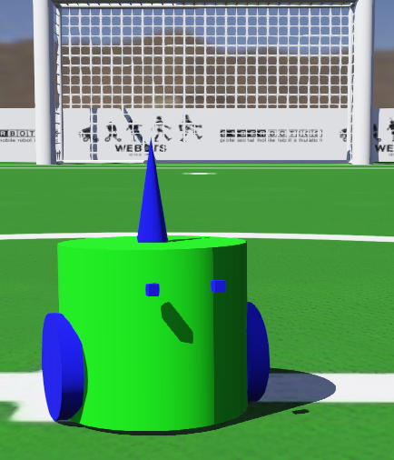

Figure Robot Front, Side and Top Views

The exterior of my robot is designed to portray a humanoid expression, with a pair of eyes that are for providing the intended human-like look only, yet it is setup in a manner that allows it carry out its objectives accurately. The main objective of the robot is to detect presence of football in field and reach it, which it achieves with the help of using the cone-shaped camera, attached via hinge joint with device tag named “camera” , on top of the robot body and the motion is carried out using 2 rotational motors present in wheels, one on each side of the body, with the device tags as “motor_1”(left-side wheel) and “motor_2”(right-side wheel) respectively. The camera on top detects its surroundings and provides information to the robot and, as a response, the robot assigns values to its’ motors’ respective speeds and carries out motion towards wherever the football may be present. The only alterations were made to the camera’s width and height, to give it a particular cone-like shape. A flowchart that showcases the robots’ primary functionalities is found below:

A diagram of a process

2-Wheeled Robot Process Flow


Figure Robotic Process Flowchart

At Initiation, Robot camera and motors (motor_1, motor_2) are turned on and its speed value is set to 2. The camera makes use of its Object Recognition feature to search the surroundings for the football. For this, the robot spins around until the football is located, after which, the motors are adjusted to keep the Football within the “Center of Camera Field of View”, until the robot has reached the football. The table below show shows the actions taken by robot before and after recognition of the football:

|  |  |
| --- | --- |
| **Condition** | **Function Executed** |
| number_of_objects == 0 | motor_1 = -SPEED/2, motor_2 = SPEED |
| objects[i].position_on_image[0] < 125 | motor_1 = -SPEED/2, motor_2 = SPEED |
| objects[i].position[0] > 0.15 | motor_1 & motor_2 = SPEED*4, |

In the first condition, if no football is visible in the camera’s field-of-view, the robot keeps spinning in an anti-clockwise direction, by reducing its’ motor_1 speed by half. During spin, if football comes into vision, then the robot begins moving towards the football by increasing both motor 1 and motor 2 speeds by up to 4 times. However, upon reaching the football, the robot stops its motion. Also, dynamic change in football position is detected by the robot and further details are discussed in the results section below.

## **Implementation:**

All robotic functionalities being carried out is programmed using a single language called C. I used this language due to its easy to comprehend nature, as I was able to quickly pick up on the knowledge regarding on the dos of using this language to make my program execute successfully. Another major reason for utilizing C is that it has a large variety of libraries and functions that can be used to interact with a majority of the low-tier robotic hardware i.e. Sensors, Actuators. This entire project was developed using Webots software, created by Cyberbotics Ltd.

## **Sources Used:**

I made use of both YouTube Tutorials and Webots manual as guidance resources for robotic design and programming:

* 2-Wheeled Robot Design: <https://www.youtube.com/watch?v=ebGJzymXv-o&t=2s&ab_channel=KajalGada>
* Controller Code to drive Robot: <https://www.youtube.com/watch?v=CDOrTKQAOqs&ab_channel=KajalGada>
* Object Recognition(YouTube): <https://www.youtube.com/watch?v=JHAWZmfY8zA&t=158s&ab_channel=Softillusion>
* [Camera Recognition](https://www.cyberbotics.com/doc/reference/camera?tab-language=c#wb_camera_recognition_enable)(Webots Reference Manual)
* Camera was integrated using camera base node.

# **Results and Evaluation**

## **Results:**

The robot’s had 3 primary objectives, the results of which are presented in the table below:

|  |  |  |
| --- | --- | --- |
| **Objective** | **DESCRIPTION** | **RESULT** |
| 1 | Move across Football Field | SUCCESS |
| 2 | Recognize Football on the Field | SUCCESS |
| 3 | Reach Football | SUCCESS |

The robot was able to successfully execute drive motion throughout the football field, by utilizing its motors 1&2, even changing its speed with regards to how much distance the robot was separated from its target football.

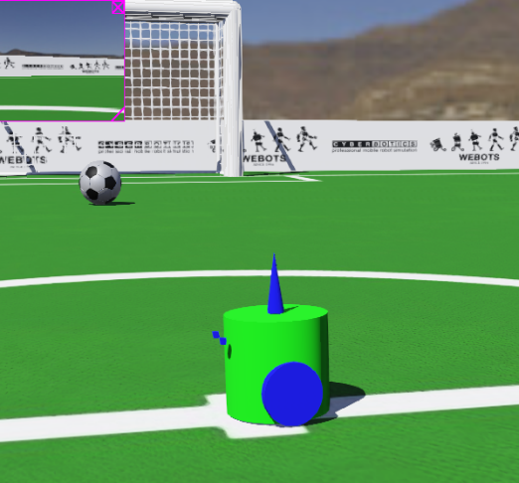 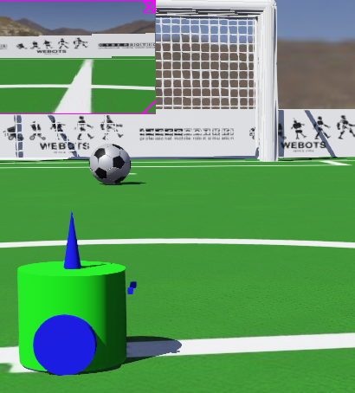

Figure Robot Before, 90 degrees & 180-degree Rotation

As can be seen in the above figures, when the football is not in the camera vision, the robot rotates anti-clockwise at the same position until the robot is detected.

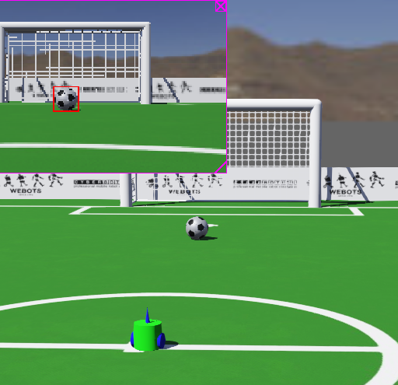

Figure Robot Detects Football

As soon as the football comes in the field of view of the camera, the object recognition feature forms a red, squared box around the football, confirming the fact that it has successfully identified the target.

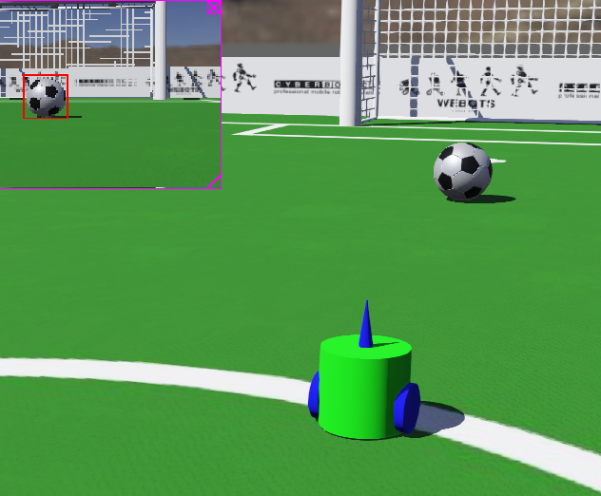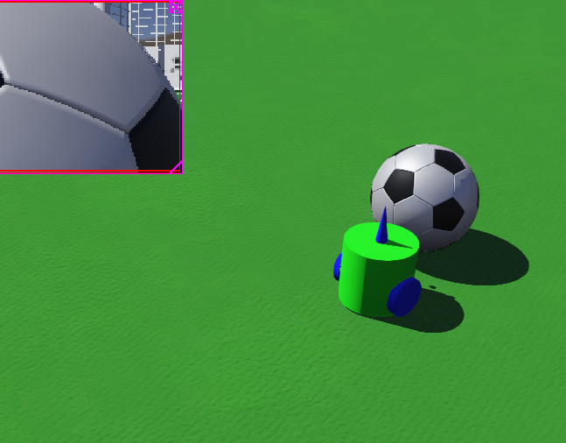

Figure Robot Moves Towards and Reaches Football

After recognizing the football, the robot begins its motion towards it. The path towards target is not completely linear, as the robot adjusts motor_1(left) to half the speed of that of the motor_2(right), yet the football always remains within camera frame until the robot collides with the football, after which its motion ceases.

## **Evaluation:**

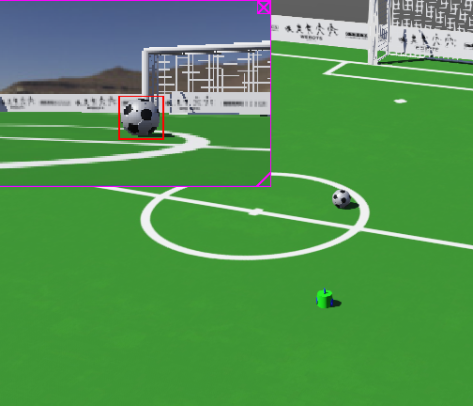

Figure Football Lifted on Top during Motion

Figure Robot Moving towards Football

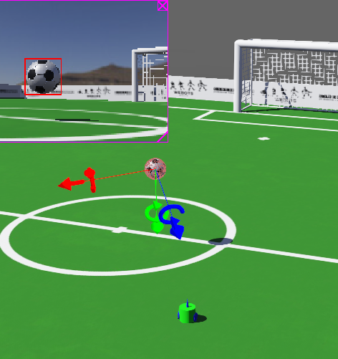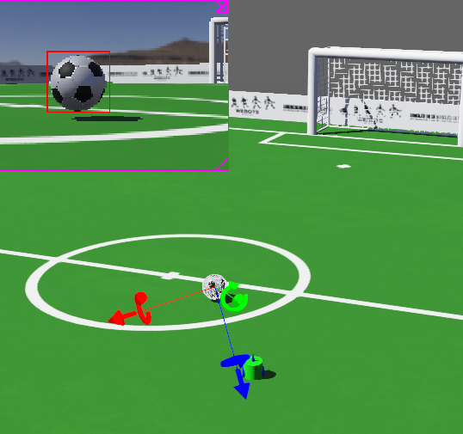

Figure Football dropped to New Position

Figure Football Moved towards left, Still in Field of View

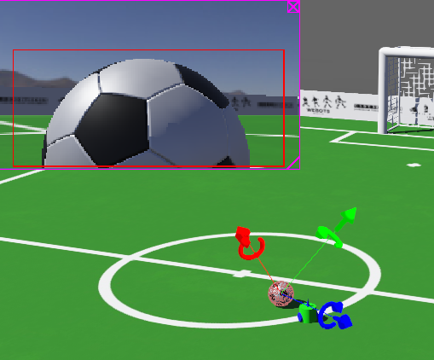

Figure Robot reaches Football at New Position

Overall, the project is considered a complete success. All the 3 primary objectives that were programmed into the robot were carried out effectively. To further test the recognition capabilities of robot camera during motion, I even changed the football’s position a couple of times to check if the camera still recognizes it. In this scenario, I found that if the football’s new position remained in any part of the camera’s current field of view, regardless of how much in the left or right direction of original position the football is placed, the robot immediately recognized it and continued its motion towards it without hesitation.

# **Conclusion:**

The entire project was based on the simulation run using the Webots Simulator by Cyberbotics, with all robot functions being programmed using C language coding functions, corresponding libraries and tools etc. If we talk about the level of success, I found that the project was 100% successful as it had carried out its objectives of Football Recognition and reaching target football, without fail. Even when I manually change the football’s position, during robot’s motion towards it, as long as the football’s new position remained in camera view, the robot was still able to continue moving towards it and reach it at its new position easily.

Furthermore, as suggestions for improving the performance and overall capabilities of the robot some of the following changes can be made to the project:

1. A hinge joint with the ability to rotate full 360 degrees: This would allow the camera to easily locate the football no matter where it is on the field rather than the robot having to rotate every time when the ball is out of its field of view
2. Obstacle Avoidance capability added to camera: In a scenario where an obstacle(s) is present, blocking the path between the football and the robot, an object avoidance capability being added, and necessary C language functions being programmed would allow the robot to maneuver around any obstacle on the field and then move towards the football.
3. Color Recognition Capability added to Camera: In an alternate scenario, in which other objects i.e. goalposts, training cones and even other types of balls similar to the football are present on the field, having Color Recognition capability would allow the robot’s camera to only recognize a set choice of RGB values(color) assigned to the target and would segment the target ball i.e. football from all other non-essential objects on the field, allowing the robot to only move towards its assigned target.